**DAILY ONLINE ACTIVITIES SUMMARY**

|  |  |  |  |
| --- | --- | --- | --- |
| **Date:** | 3/07/2020 | **Name:** | Krishnitha |
| **Sem & Sec** | 4th sem, A Section | **USN:** | 4AL18CS039 |
| **Online Test Summary** | | | |
| **Subject** | NA | | |
| **Max. Marks** | NA | **Score** | NA |
| **Certification Course Summary** | | | |
| **Course** | Cloud Support Associate | | |
| **Certificate Provider** | AWS Educate | **Duration:** | 4 hrs |
| **Coding Challenges** | | | |
| **Problem Statement:**  -- | | | |
| **Status:** -- | | | |
| **Uploaded the report in GitHub** | | YES | |
| **If yes Repository name** | | [--](https://github.com/krishnitha/Python-coding) | |
| **Uploaded the report in slack** | | YES | |

**Certification Course Details:**

Today I have continued the course “Cloud Support Associate” by AWS Educate. In this course today I learnt about ‘Introduction of cloud support associate ’and ‘Platforms’. Today I have completed two modules of this course. And I have also completed the assessment of this module.

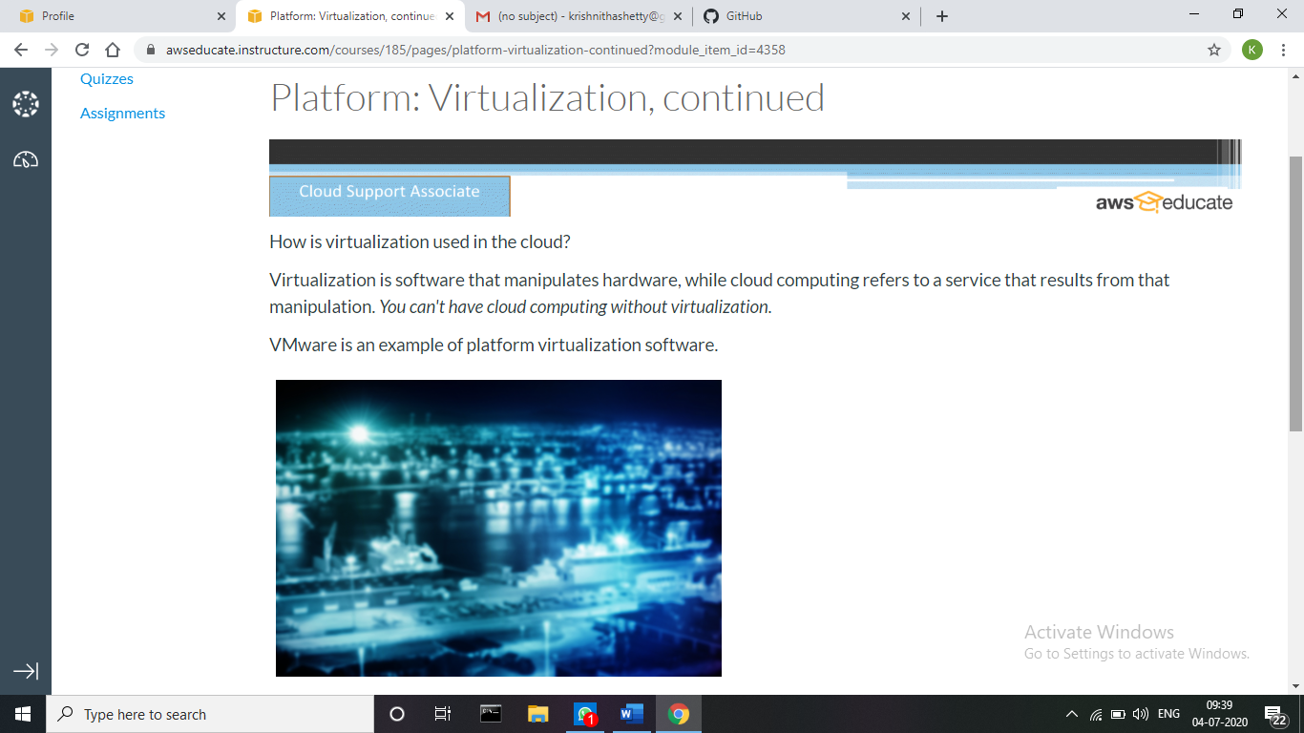

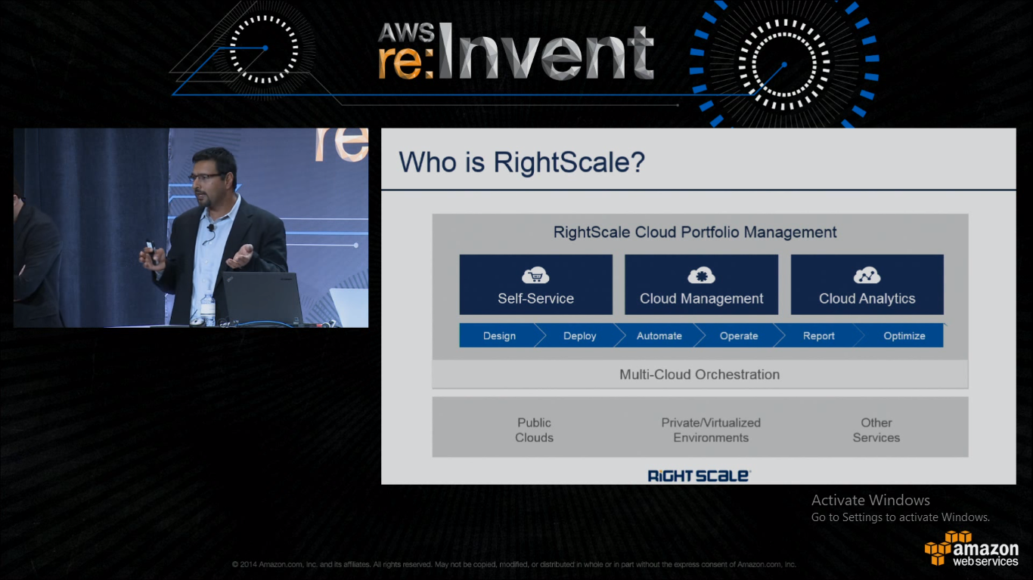

**Webinar Details:**

Today I attended a webinar on “Loops and conditional statements, Array” by Assistant professor Ms. Megha D. Hegde. The session was very interesting. There was a quiz conducted based on the webinar, I scored 20/30.

